PROJECT DOCUMENTATION
PocketSmart AI : Your Smart Budget & Recommendation Assistant

Team ID: SWTID-2026-2280
Team Size: 4
Team Leader: RAMAA LAKSHMI P
Email: ramaalakshmipitti@gmail.com
Team member: AAMINA THABASUM M
Email: thabasumaamina@gmail.com
Team member: JANANI D
Email: jananijani97@gmail.com
Team member: MITHRA K
Email: kmithra2411@gmail.com

PocketSmart AI: Your Smart Budget & Recommendation Assistant

Project Description

Managing a personal budget can become difficult when a user needs to compare many products, services, prices, and alternatives. PocketSmart AI is designed as a GenAI-powered planning assistant that combines budget control with personalized recommendations. It accepts the user's spending limit, requirements, preferences, and planning context, then organizes suitable choices into practical recommendations. The system can work with information from services such as Amazon, Flipkart, IKEA, Swiggy, Zomato, OYO, and similar platforms. The application supports home planning, event preparation, and jewelry selection while keeping the user's target budget in focus. Category-specific forms and an AI recommendation layer make the planning process more structured and reduce repeated manual comparison.
Scenario 1: Home Interior Planning with Smart Budget Allocation
In the Home Budget Planner, the user enters the planned spending amount and provides details about rooms and required items such as lights, fans, tables, storage units, and other furnishings. The recommendation engine studies these requirements and identifies suitable alternatives from sources such as IKEA and Amazon. The suggestions are organized by category and consider practical needs, preferred appearance, and available spending capacity so the user can create a balanced interior plan.
Scenario 2: AI-Based Party Budget Planning
The Party Planner collects the available budget, guest count, function type, and venue details. Based on these inputs, the system organizes expected spending for food, decoration, entertainment, accommodation, and other event needs. Services such as Swiggy, Zomato, and OYO can be considered when generating options. The recommendations are adjusted for occasions such as birthdays, corporate functions, and weddings, helping the user prepare an event plan without manually calculating every category.
Scenario 3: Jewelry Recommendations for Occasions
The Jewelry Budget Planner uses the user's budget, occasion, preferred style, and optional outfit image to create suitable accessory suggestions. When an image is supplied, the AI can use visible styling information such as colors and overall appearance as additional context. It then organizes jewelry choices from sources such as Amazon and Flipkart according to the selected occasion and style while keeping the recommendations aligned with the planned spending limit.

Architecture Overview
PocketSmart AI follows a modular architecture in which the interface, backend services, AI layer, and recommendation modules work together. User budgets, preferences, category selections, and optional images are converted into structured inputs before being processed by the recommendation engine. The design separates presentation, application logic, authentication, and AI processing so that the system can be maintained and extended more easily.

Core Technologies
- Flask: Provides the application layer for request handling, routing, user sessions, and communication between the interface and recommendation services.
- Gemini 1.5 Flash Pro: Understands user requirements, processes optional images, interprets budget information, and produces structured recommendations for the selected planning category.
- Third-party APIs and service sources: Provide product, food, venue, accommodation, and other information that can be used to build relevant recommendation choices.
- Frontend (HTML/CSS + JavaScript): Collects user information through interactive forms and presents the generated recommendations in an organized and readable format.
Component-Wise Architecture
Component | Description
Frontend UI | Responsive HTML/CSS interface for collecting budgets, preferences, category details, and optional images, then displaying generated recommendations.
Flask Backend | Application layer responsible for routes, sessions, request handling, and communication between the interface and AI services.
Gemini AI Layer | Processes user inputs with Gemini 1.5 Flash Pro to interpret requirements, analyze optional images, and generate category-specific recommendations.
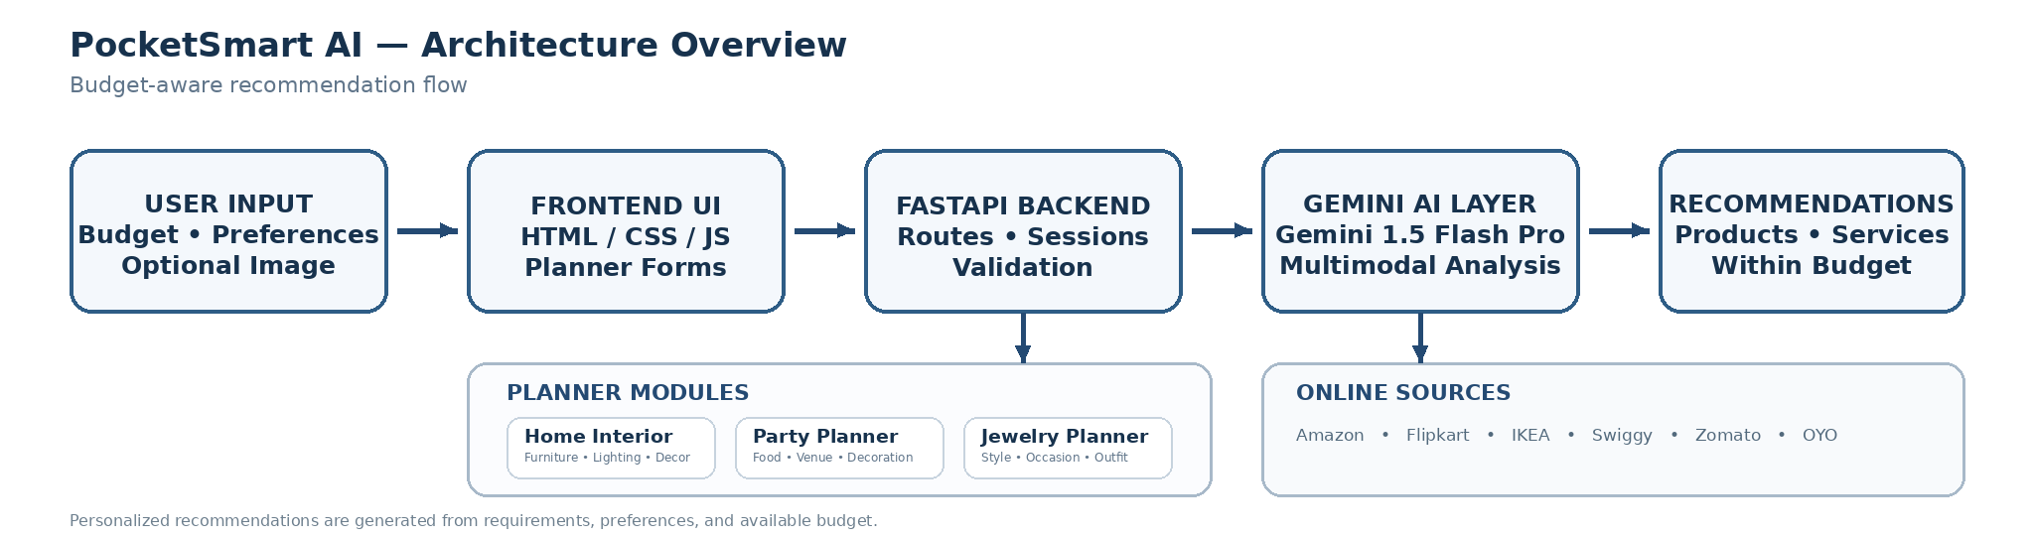
Pre-requisites
- IBM Cloud Account Setup: Access to an IBM Cloud account and its required console services.
- Watsonx Access and Configuration: Basic access and configuration knowledge for Watsonx services.
- Python Basics: Familiarity with Python syntax, functions, packages, and API communication.
- FastAPI Framework: Basic understanding of FastAPI routes, requests, responses, and application structureProject Workflow

1. Gemini AI Setup & Initialization
- Activity 1.1: Configure the required cloud or AI platform access and enable Gemini API connectivity for the application.
- Activity 1.2: Create API credentials, define suitable usage limits, and verify support for both text and image inputs.
- Activity 1.3: Improve the prompts so that budgets, requirements, preferences, and recommendation criteria are interpreted consistently.

2. Core Functionality Development
- Activity 2.1: Build the backend structure for routing, authentication, sessions, and the three planner modules.
- Activity 2.2: Develop separate endpoints for Home, Party, and Jewelry planning requests.
- Activity 2.3: Connect each planner with category-specific prompts and templates that can accept normal text and optional images.

3. Backend Implementation (app.py)
- Activity 3.1: Define the main application routes, including /generate-home, /generate-party, and /generate-jewelry.
- Activity 3.2: Organize the backend into separate modules for routes, services, and data models.
  - routes/: Contains application endpoints and request-handling logic.
  - services/: Contains recommendation processing and AI communication functions.
  - models/: Contains structures used for validating and exchanging input and output data.
- Activity 3.3: Configure CORS for frontend communication and provide basic session handling for authenticated users.
- Activity 3.4: Use mock API responses or simulated external-source data during development and testing.

4. UI Development
- Activity 4.1: Create responsive forms for each planning category.
  - Home Interior Planner: Collects room information, required quantities, preferences, and budget details.
  - Party Planner: Collects event type, spending limit, guest count, venue information, and related requirements.
  - Jewelry Planner: Collects budget, occasion, style preferences, and an optional outfit image.
- Activity 4.2: Use JavaScript to update the result area dynamically and present recommendation details in a clear format.

5. Testing & Optimization
- Activity 5.1: Test all three planners with different budgets, categories, preferences, and realistic usage situations.
- Activity 5.2: Check recommendation relevance, budget alignment, response consistency, and the accuracy of information supplied by external sources.
- Activity 5.3: Refine prompts, strengthen validation rules, and handle unusual or incomplete user inputs.
- Activity 5.4: Provide suitable fallback recommendations when the AI cannot produce enough matching results.

MILESTONE 1: Gemini AI Initialization
The first milestone establishes the AI foundation required for PocketSmart AI. The application uses Gemini 1.5 Flash Pro to understand user requests, interpret budget information, and generate recommendations. This stage prepares authenticated API access and verifies that the system can process both text and image information, which is especially useful for the Jewelry Planner. A reliable AI connection is necessary before the planning modules can perform budget-aware and personalized recommendation tasks.

● Activity 1.1: Set up Google Cloud account and activate Gemini API access

Create or access the required Google Cloud account and open the services needed by the project.

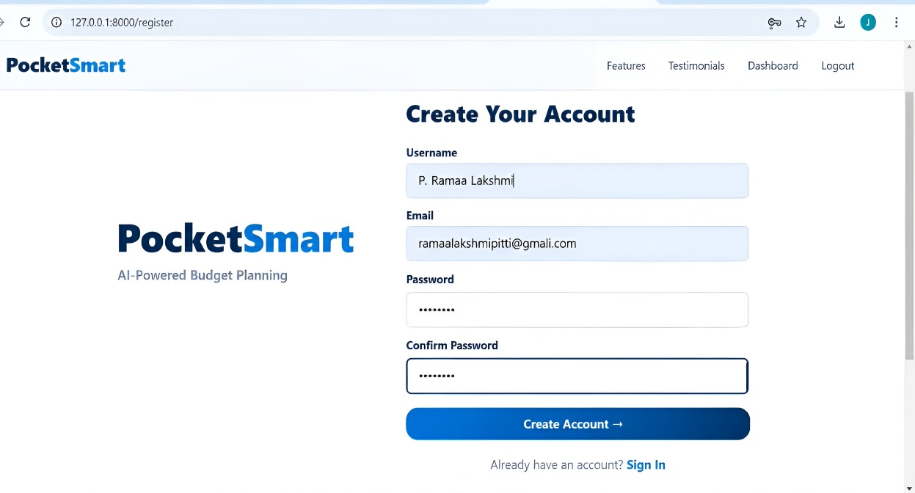

Complete the configuration steps and create an API key for application-level communication.

Review the available model configuration and select the model required by the project according to the relevant API documentation.
Activity 1.2: Set up API access and application permissions
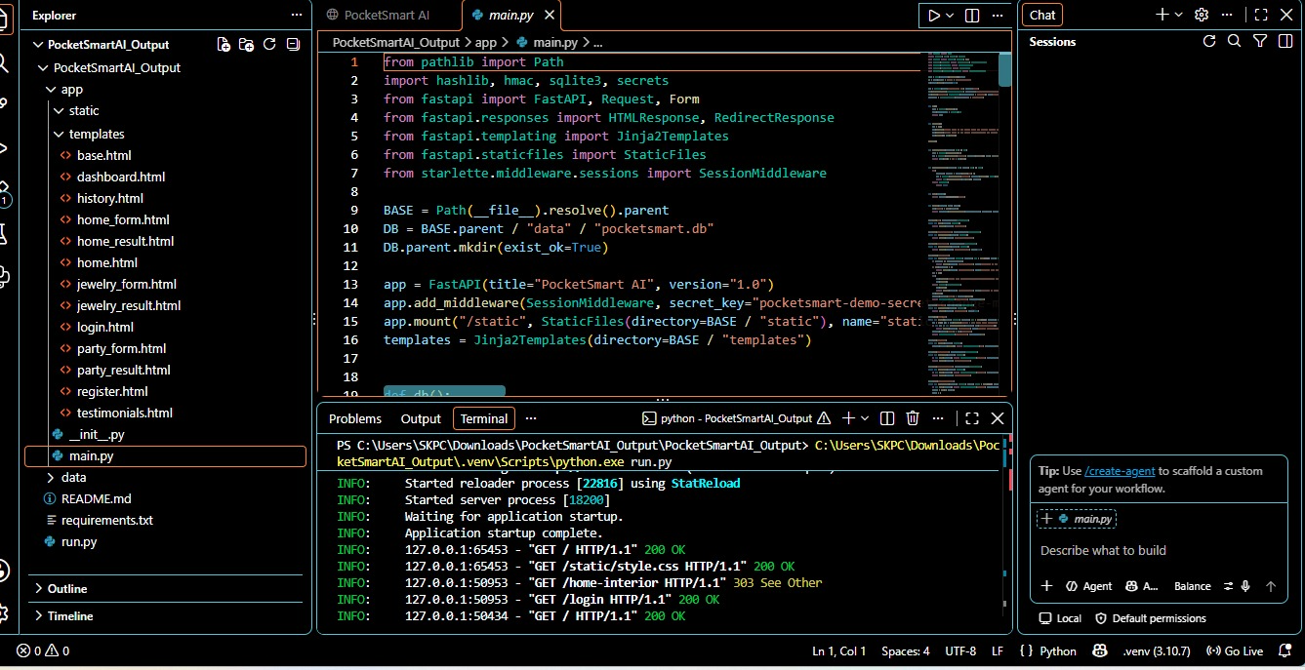

Open the API credential area and create a new application key with the required access.

Store the generated key securely and reference it through the application's configuration rather than exposing it in source code.
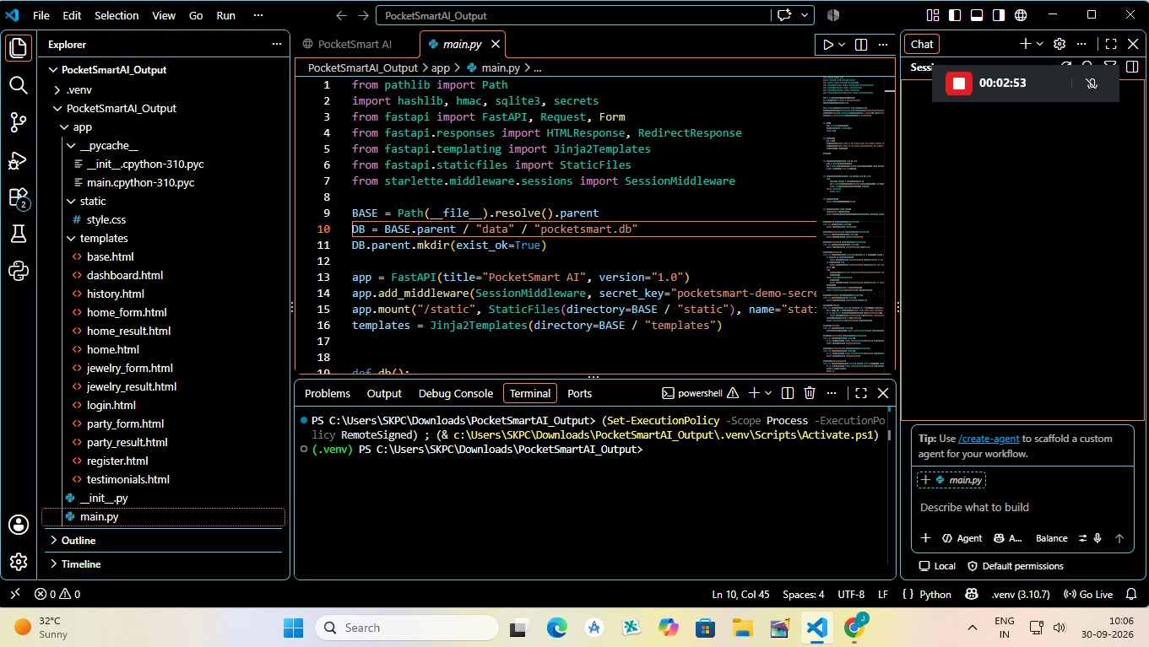

- Activity 1.3: Verify Gemini API communication
  - Send a simple Python request to confirm that the application can communicate successfully with the Gemini service.
  - 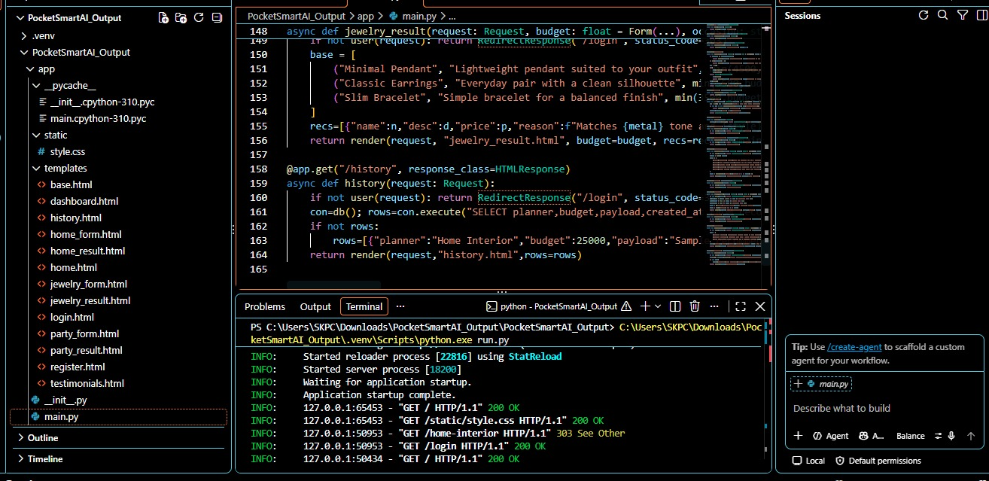

  - Test both text-only requests and combined image-plus-text requests to confirm multimodal processing.

MILESTONE 2: Development of Core Functionalities
This milestone develops the central application logic using FastAPI and Gemini 1.5 Flash Pro. The backend accepts budget values, preferences, planning details, and optional image information, then converts them into category-specific recommendation requests. It also manages prompt construction, AI communication, planner logic, authentication support, and fallback handling. Shared utility functions keep budget interpretation, category separation, and multimodal processing consistent across the application.
File Explorer Structure
Activity 2.1: Fast API Instilization and import libraries
- Import the packages needed for API creation, authentication, environment configuration, template rendering, request handling, and application services.
- Fast API Initialization
- Load environment configuration from the .env file so sensitive settings and application variables can be managed separately from the main source code.
Activity 2.2: Main Functionality code routings
- /generate-home: Accepts home-planning details and prepares recommendations for furniture, lighting, decoration, storage, and related requirements.
- Invoke the home recommendation service with the submitted budget, room information, quantities, and preferences
- Connect the home recommendation flow with relevant product sources such as Amazon, Flipkart, and IKEA
- /generate-party: Receives event details and prepares suggestions for food, venues, decoration, entertainment, and other requirements
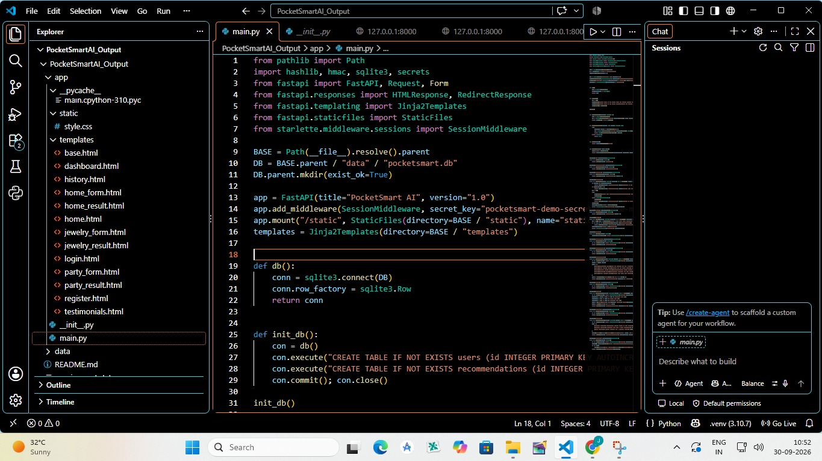
- Invoke the party recommendation service using the submitted event information, guest count, budget, and preferences.
- Connect the party planning flow with relevant product and service sources where applicable.
- Apply conditional logic to classify the user's requirements and return recommendations that match the selected category.
- /generate-jewelry: Accepts text details and optional image information to generate jewelry suggestions that fit the selected occasion and style.
- async def jewelry_planner(request: Request, current_user: UserInDB = Depends(get_current_active_user)):
- """Jewelry budget planner page"""
- return templates.TemplateResponse("jewelry_planner.html", {"request: request, "user": current_user})
- Invoke the recommendation service with the jewelry budget, occasion, style information, and optional outfit context.
- Connect the jewelry recommendation flow with suitable product sources such as Amazon and Flipkart.
Activity 2.3: Login and Register page routings
- Login page
/login: Validates registered user information and creates an authenticated session after successful verification.
- Register Page
/register: Collects the information required for a new account and stores the registration details for later authentication.
- Logout Page
/logout: Closes the current authenticated session and returns the user to the login page.
Activity 2.4: Ensure modular code structure
- /token: Creates an authentication token after successful login so protected API endpoints can be accessed only by authorized users.
- /session-info: Returns information about the active session, including the current user and authentication state.
- /session-data: Provides session information that can support personalization and recommendation history.

MILESTONE 3: Backend – FastAPI Integration (main.py)
This milestone implements the FastAPI backend as the communication layer between the frontend and the Gemini-based recommendation system. Separate routes are maintained for Home, Party, and Jewelry planning, while authentication and session services support personalized use. CORS settings allow frontend communication, and structured request and response models help keep data exchange consistent.
- Activity 3.1: Create FastAPI Routes
- 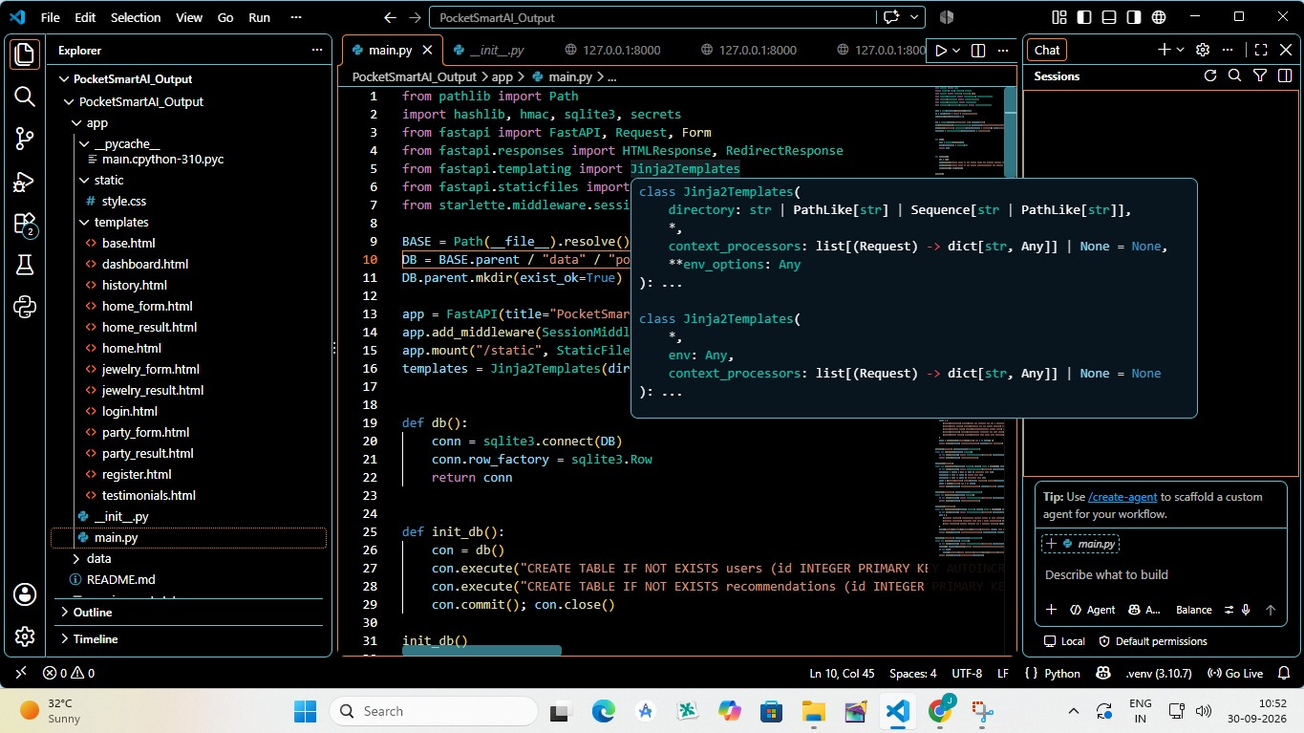
  - Home Planner (/generate-home): Receives home preferences and budget information and returns suitable product recommendations. Party Planner (/generate-party): Uses event type, guest count, budget, and related details to generate suggestions for food, venues, decoration, and other event needs.
  - Jewelry Planner (/generate-jewelry): Processes text details and optional outfit images to recommend jewelry that fits the selected occasion and style.
  - User Auth (/register, /login, /logout, /token): Supports registration, login verification, authentication, token creation, and session control.
  - Session Info (/session-info, /session-data): Supplies session information that can be used during personalized AI interactions.
- Activity 3.2: Modular Architecture Setup
/recommendations-details: Returns detailed AI-generated recommendations based on the selected category, budget, preferences, and planning requirements.
- Activity 3.3: CORS & Static Routing
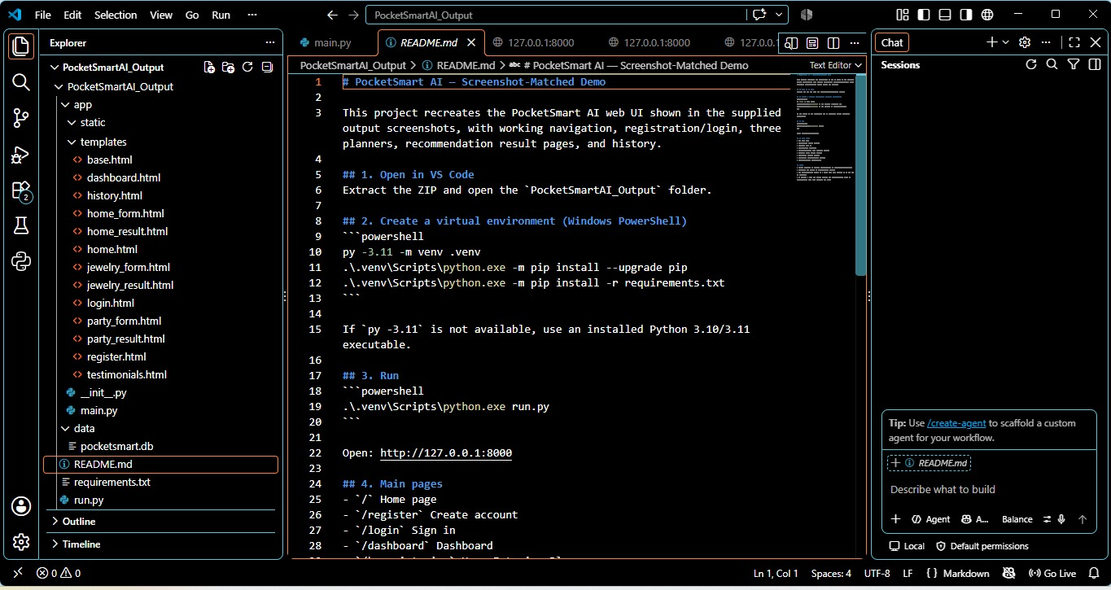
/history: Displays earlier recommendation requests and results so users can review previous plans and reuse useful information.
- Activity 3.4: Startup and main function
/startup: Loads required configuration and initializes essential application services when the FastAPI server starts.
__main__: Acts as the execution entry point and launches the FastAPI application through Uvicorn when the program is run directly.

MILESTONE 4: UI Development
This milestone builds the user-facing part of PocketSmart AI with HTML, CSS, and Jinja2 templates. The interface provides clear forms for Home Interior, Party, and Jewelry planning and sends the collected information to FastAPI endpoints. Generated results are displayed in an organized format, while authenticated sessions allow the application to support personalized interaction and saved information.
Activity 4.1: Develop HTML Frontend Interface
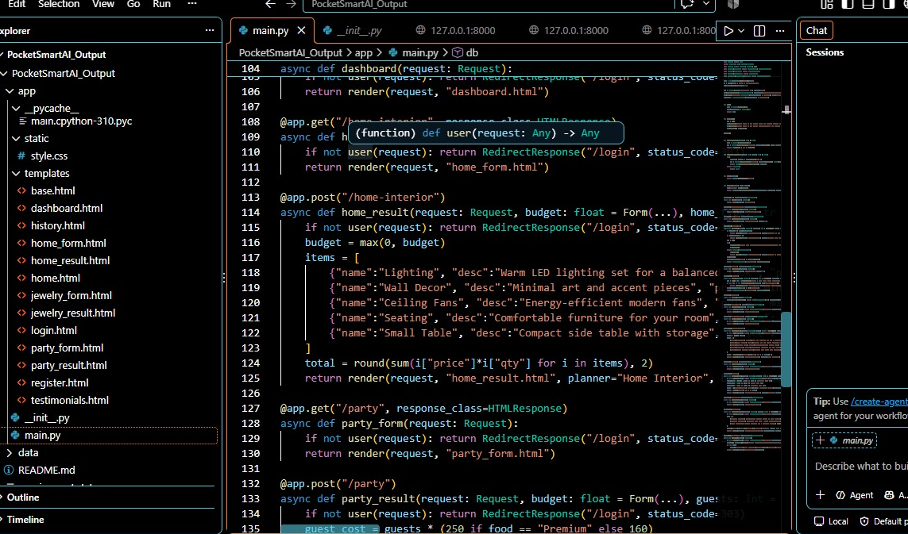
- Create a landing page where users can enter their budget and choose among the Home, Party, and Jewelry planners.
- Create individual planner forms and connect each form to the appropriate FastAPI POST endpoint.
- Display AI results using structured cards that can show product or service names, important details, prices, and recommendation information.

Templates Directory Structure:

MILESTONE 5: Testing & Optimization

This milestone evaluates the reliability, consistency, usability, and contextual quality of the PocketSmart AI recommendation process. Testing covers Home Interior, Party Planning, and Jewelry use cases with different budgets and preferences. The system is improved by refining prompts, strengthening session handling, validating inputs, and ensuring that the interface remains usable across different screen sizes.

Activity 5.1: Test with Real-World Budget Inputs Across Domains
Perform complete workflow testing with different budgets and preferences for the following planning areas:

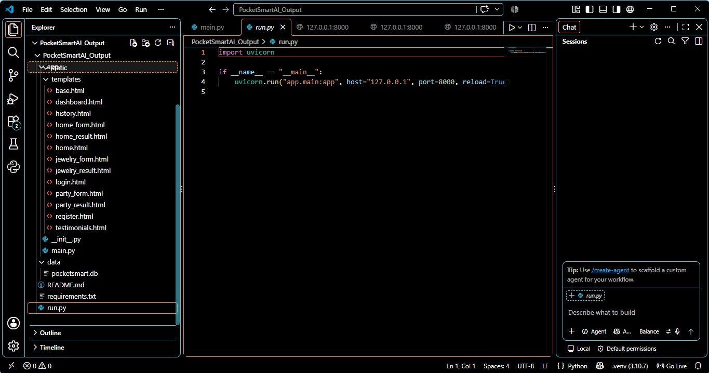

Home decoration plans using product information from sources such as IKEA and Amazon.

Party requirements covering food, accommodation, decoration, and related services from sources such as Swiggy, Zomato, and OYO.

Jewelry recommendations using outfit style, occasion, budget, and optional image information.

Home Page

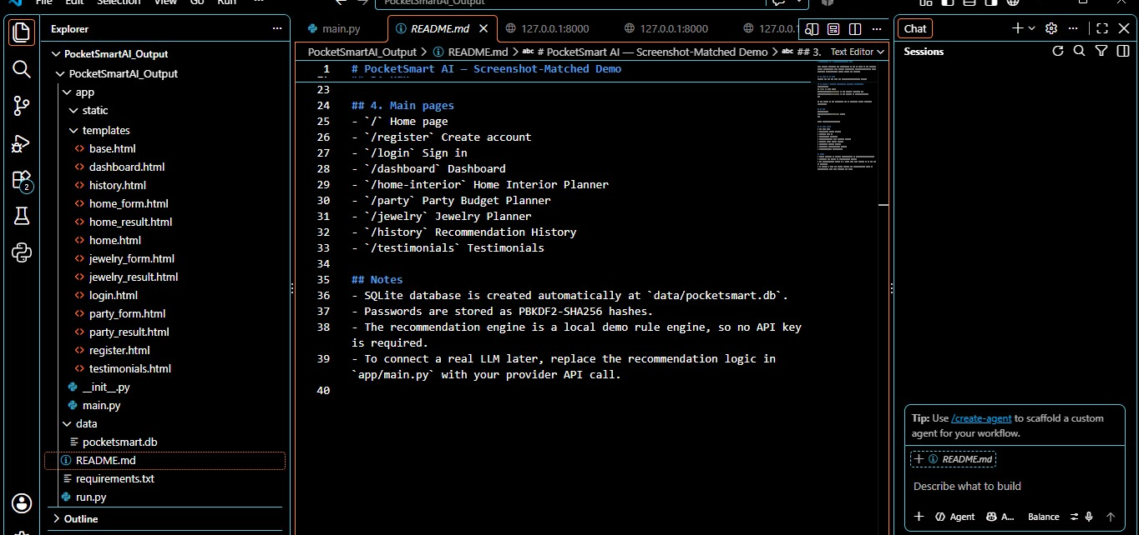

Home Page: Introduces PocketSmart AI and provides access to the available planning modules and major user actions
- Testimonials Page
Testimonials Page: Displays user feedback or example experiences that demonstrate how the planning features can be used.
- Footer Part
- Register Page
Register Page: Allows new users to create an account and begin using personalized budget and recommendation features.
- Login Page
Login Page: Authenticates registered users and provides access to the dashboard and saved information.
- User Dashboard
User Dashboard: Presents recent recommendations, stored requests, and personalized information for the signed-in user.
Home Interior Budget Planner Page: Collects room requirements, decoration preferences, and budget details before generating suitable recommendations from available sources.
Home Interior Recommendations Page: Shows AI-generated home product options organized around the user's budget, requirements, and preferred style.
Party Budget Planner Page: Collects event details, guest count, budget, and planning preferences to prepare suitable venue, food, and decoration suggestions.
Party Budget Recommendations Page: Presents the generated event choices in an organized view, covering areas such as food, venues, decoration, and other submitted requirements.
Jewelry Budget Planner Page: Collects the occasion, budget, preferred style, and optional outfit image so the system can prepare relevant jewelry suggestions.

Jewelry Budget Recommendations Page: Presents jewelry choices selected through AI analysis of the submitted occasion, style, outfit context, and spending limit.

Recommendation History Page: Stores previous planning requests and generated results so users can review earlier recommendations and reuse useful planning information
Conclusion
PocketSmart AI is designed as a digital budgeting and recommendation assistant that brings planning information into one structured workflow. It combines FastAPI, Gemini 1.5 Flash Pro, user inputs, and optional images to generate recommendations for home interiors, event arrangements, and jewelry selection. The application separates its frontend, backend, authentication, AI processing, and recommendation modules to support clear maintenance and future expansion. Users can enter their requirements, receive organized choices, and review earlier recommendation activity without repeatedly starting the planning process from the beginning. Overall, the project demonstrates how generative AI and web technologies can be combined to support practical, budget-aware decision making with a focus on personalization, organization, and reduced manual comparison.
The completed system brings together account management, planning forms, recommendation generation, and history features into a single application flow. By organizing recommendations around the user's budget and requirements, PocketSmart AI provides a structured approach to everyday planning while leaving the final selection to the user.

